Project Report: Comprehensive Analysis of IBS Patient Characteristics

Notebook: MDRecord_fullfeatures

IBS_Med_Original_Group_FullFeatures

1. Introduction
This project aimed to comprehensively analyze patient characteristics to distinguish between Irritable Bowel Syndrome (IBS) patients and healthy controls. The analysis involved extensive data preprocessing, application of various dimensionality reduction techniques, univariate and multivariate statistical tests, and machine learning classification models. A key focus was to identify features that significantly differentiate the groups, assess model performance, and extract feature importance to understand the biomedical relevance of the findings, paving the way for potential clinical applications and future research.

2. Data Preprocessing Summary
The initial dataset, IBS_Med_Original_Group_FullFeatures.xlsx, underwent the following preprocessing steps:
- Initial Data Loading: Data was loaded into a DataFrame df.
- Handling 'n/a' and 'N/A': Case-insensitive 'n/a' and 'N/A' values were replaced with np.nan in df_processed to correctly identify missing data.
- Dropping Columns with Excessive Missing Values: Columns with 30 or more missing values were dropped, resulting in df_cleaned (reduced from 46 to 38 columns). This removed features deemed too sparse for reliable analysis.
- Group-wise Imputation: Missing numerical values were imputed with the median and categorical values with the mode, separately for 'IBS' and 'Control' groups in df_imputed_groupwise. This ensured no missing values remained.
- Feature Engineering (BMI Calculation): Body Mass Index (BMI) was calculated using 'weight' (lbs) and 'height' (inches) from df_imputed_groupwise, with height string values parsed and converted to inches.
- One-Hot Encoding: All categorical features were converted into numerical binary features using one-hot encoding (pd.get_dummies) to create df_encoded. drop_first=True was used to prevent multicollinearity, resulting in a DataFrame with 61 samples and 185 columns (including the target Group_IBS).
- Feature Scaling: For dimensionality reduction and classification, numerical features (excluding the target) were standardized using StandardScaler to create X_scaled.
These steps prepared the data for robust statistical and machine learning analyses.

3. Dimensionality Reduction Analysis
Four dimensionality reduction techniques were applied to X_scaled, and their ability to separate 'IBS' and 'Control' groups was assessed using visual inspection and silhouette scores.
- Principal Component Analysis (PCA):
  - Plot: Showed some overlap between groups, but a general trend of separation was visible, especially with 95% confidence ellipses.
  - Explained Variance: PC1 and PC2 explained 5% each, totaling 10% of the variance.
  - Silhouette Score: 0.481 (Highest among the four).
  - Biomedical Implication: Suggests that linear combinations of features capture moderate distinction between groups, indicating that global, linearly separable factors contribute to the disease state.
- Principal Coordinate Analysis (PCoA):
  - Plot: Showed substantial overlap; visual separation was minimal.
  - Explained Variance: PC1 explained 60% and PC2 explained 9%, totaling 69% of the variance.
  - Silhouette Score: 0.049 (Very low, close to zero).
  - Biomedical Implication: Using Bray-Curtis distance on this dataset, the groups were highly intertwined compositionally. This indicates that a simple compositional dissimilarity metric might not effectively separate IBS patients from controls based on the current feature set.
- t-Distributed Stochastic Neighbor Embedding (t-SNE):
  - Plot: Visually distinct, clear clusters with good separation.
  - Silhouette Score: 0.138.
  - Biomedical Implication: t-SNE effectively preserves local data structures, suggesting that IBS and Control patients form clear, distinct groups in their local feature neighborhoods due to complex, non-linear relationships between features. However, the lower silhouette score compared to PCA hints that while local separation is good, global separation might not be as strong.
- Uniform Manifold Approximation and Projection (UMAP):
  - Plot: Similar to t-SNE, presented visually clear and well-separated clusters.
  - Silhouette Score: 0.128.
  - Biomedical Implication: UMAP, like t-SNE, highlights that complex, potentially non-linear, interactions between patient characteristics and measurements exist that strongly differentiate the two groups. These methods are excellent for generating hypotheses about subgroups or distinct disease mechanisms.
Summary of Dimensionality Reduction: While PCA offered the best quantitative separation based on the silhouette score, t-SNE and UMAP provided strong visual separation, suggesting that non-linear relationships are key to distinguishing IBS patients.

4. Multivariate Statistical Tests
Three multivariate statistical tests were conducted to assess overall differences between the IBS and Control groups.
- Multivariate Analysis of Variance (MANOVA):
  - Result: Pillai's Trace p-value of 0.000 (highly significant).
  - Interpretation: Indicated a very strong statistical difference in the multivariate means of the feature profiles (after PCA dimensionality reduction) between the IBS and Control groups.
  - Biomedical Implication: Supports the idea that IBS is associated with a distinct overall 'state' as captured by the combined biomedical and lifestyle features.
- Permutational Multivariate Analysis of Variance (PERMANOVA):
  - Result: p-value of 0.036 (statistically significant).
  - Interpretation: Confirmed a statistically significant difference in the overall multivariate composition of the IBS and Control groups based on the Bray-Curtis distance matrix.
  - Biomedical Implication: Reinforces that the clustering of individuals in the multivariate space is not random but structured by group membership, indicating that the overall 'profile' of features differs.
- Analysis of Similarities (ANOSIM):
  - Result: R-statistic of 0.122 and p-value of 0.021 (statistically significant).
  - Interpretation: The low p-value indicated a significant difference, and the positive R-statistic suggested that samples within the same group are more similar to each other than to samples from different groups, though the separation was not extremely strong.
  - Biomedical Implication: Corroborated MANOVA and PERMANOVA, confirming a significant distinction between the IBS and Control groups and implying detectable within-group similarities and between-group differences.
Summary of Multivariate Tests: All three tests consistently demonstrated a statistically significant difference between IBS and Control groups across their multivariate feature profiles. This provides a strong statistical foundation for further exploration and classification.

5. Univariate Statistical Tests
Univariate tests were performed to identify individual features that differ between groups.
- Mann-Whitney U Test:
  - Result: Identified numerous features with statistically significant differences (p < 0.05). These included specific categories within:
    - Demographic/Socioeconomic: Educational Level, Ethnicity/Race, Marital Status, Household Income, Number of people in household, Height.
    - Medical History/Comorbidities: Alcohol use, colonoscopy/endoscopy history, diabetes, high cholesterol, diagnosis of depression/anxiety, prescribed antidepressants.
    - Dietary Habits: Spicy food consumption, raw/uncooked food, vegetables causing flatulence, acidic fruits, non-lean meat, seeds/nuts, dressings/sauces/pickles, whole grain breads.
  - Biomedical Implication: Highlights specific demographic, medical history, and especially dietary patterns as key distinguishing factors.
- Kruskal-Wallis H-Test:
  - Result: Largely matched the significant features identified by the Mann-Whitney U test, reinforcing the findings.
  - Biomedical Implication: The consistency across these non-parametric tests strengthens the confidence in these identified features as genuine differentiators.
- Independent t-test (Welch's) for BMI, Height, and Weight:
  - Result:
    - Height: p-value = 0.360 (Not significant)
    - Weight: p-value = 0.316 (Not significant)
    - BMI: p-value = 0.054 (Not significant, though close to threshold)
  - Biomedical Implication: No statistically significant difference in the mean height, weight, or BMI between IBS and Control groups, suggesting these general anthropometric measures are not primary discriminators.
Summary of Univariate Tests: Many individual features, particularly dietary habits, mental health comorbidities, and certain demographic factors, significantly differ between IBS and Control groups. However, basic anthropometric measures like BMI, height, and weight do not show significant mean differences.

6. Classification Model Performance (Full Features)
Several classification models were trained and evaluated using the full set of encoded features (X_clf, y_clf), with hyperparameter tuning via Leave-One-Out Cross-Validation (LOOCV) and evaluation on a 70/30 train-test split.
Model | Best Hyperparameters | LOOCV Mean Accuracy (± Std) | Train-Test Split Accuracy | Train-Test Split Macro Precision | Train-Test Split Macro Recall | Train-Test Split Macro F1-Score
Logistic Regression | {'C': 100, 'penalty': 'l1'} | 0.934 (±0.248) | 0.947 | 0.938 | 0.958 | 0.945
Random Forest | {'max_depth': 10, 'min_samples_split': 2, 'n_estimators': 100} | 0.918 (±0.274) | 0.947 | 0.962 | 0.929 | 0.942
Decision Tree | {'max_depth': None, 'min_samples_split': 2} | 0.787 (±0.410) | 0.947 | 0.938 | 0.958 | 0.945
K-Neighbors | {'metric': 'manhattan', 'n_neighbors': 5, 'weights': 'uniform'} | 0.770 (±0.421) | 0.684 | 0.710 | 0.720 | 0.683
SVM | {'C': 1, 'kernel': 'linear'} | 0.836 (±0.370) | 0.947 | 0.938 | 0.958 | 0.945
Naive Bayes | {'var_smoothing': 1e-07} | 0.803 (±0.398) | 0.895 | 0.929 | 0.857 | 0.878
- Key Finding: Logistic Regression, Random Forest, Decision Tree, and SVM models achieved high accuracies on the single test split (0.947). However, LOOCV accuracies provided a more realistic and robust estimate of performance, with Logistic Regression having the highest LOOCV mean accuracy of 0.934.
- Biomedical Implication: The strong performance of several models indicates that the collected features are highly predictive of IBS status. This suggests a significant potential for developing diagnostic or screening tools based on these patient characteristics. The difference between test-split accuracy and LOOCV accuracy highlights the importance of robust validation methods on small datasets to avoid overfitting.

7. Classification Model Performance (Dietary Features Only)
Models were re-evaluated using only the dietary features identified as significant by univariate tests.
Model | Best Hyperparameters | LOOCV Mean Accuracy (± Std) | Train-Test Split Accuracy | Train-Test Split Macro Precision | Train-Test Split Macro Recall | Train-Test Split Macro F1-Score
Logistic Regression | {'C': 10, 'penalty': 'l2'} | 0.820 (±0.384) | 0.789 | 0.793 | 0.744 | 0.756
Random Forest | {'max_depth': None, 'min_samples_split': 5, 'n_estimators': 100} | 0.770 (±0.421) | 0.789 | 0.793 | 0.744 | 0.756
Decision Tree | {'max_depth': 5, 'min_samples_split': 5} | 0.803 (±0.398) | 0.737 | 0.718 | 0.702 | 0.708
K-Neighbors | {'metric': 'euclidean', 'n_neighbors': 3, 'weights': 'distance'} | 0.770 (±0.421) | 0.842 | 0.840 | 0.815 | 0.825
SVM | {'C': 1, 'kernel': 'linear'} | 0.787 (±0.410) | 0.737 | 0.718 | 0.702 | 0.708
Naive Bayes | {'var_smoothing': 1e-06} | 0.754 (±0.431) | 0.737 | 0.722 | 0.732 | 0.725
- Key Finding: Performance generally decreased when using only dietary features compared to the full feature set. K-Neighbors achieved the highest test split accuracy (0.842) for this subset, while Logistic Regression had the highest LOOCV mean accuracy (0.820).
- Biomedical Implication: While dietary habits are significant, they alone do not achieve the same predictive power as the full feature set, suggesting that IBS etiology is multifactorial and involves more than just dietary factors. However, the respectable accuracies with only dietary features still highlight their important role.

8. Feature Importance Analysis
Insights were gathered from Random Forest, Logistic Regression coefficients, and SHAP values.

a) Random Forest Feature Importance (Top 10)
- ethnicity/race_Asian American (0.065)
- colonoscopy in the past 5 years_yes (0.046)
- how often were seeds and nuts consumed in the past month_2-3 times per week (0.045)
- weight (0.038)
- Marital status_Married (0.030)
- how often were seeds and nuts consumed in the past month_1-2 times per week (0.028)
- diagnosed with anxiety_yes (0.026)
- Educational Level_High school (0.025)
- zipcode (0xxxx)_8021 (0.024)
- dx of depression_yes (0.021)

b) Logistic Regression Coefficients (Top 10 by absolute value)
- ethnicity/race_Asian American (1.02)
- how often were seeds and nuts consumed in the past month_2-3 times per week (0.96)
- how often were seeds and nuts consumed in the past month_2-3 times in the past month (0.94)
- Marital status_Married (0.69)
- colonoscopy in the past 5 years_yes (0.66)
- Educational Level_Post-Graduate (0.56)
- zipcode (0xxxx)_8021 (0.55)
- Educational Level_High school (0.55)
- how often was acidic fruits consumed in the past month_3-4 times per week (0.54)
- Number of people in household_2 (0.53)

c) SHAP (SHapley Additive exPlanations) for Logistic Regression
- Summary Plot (Global View): Confirmed features like ethnicity/race_Asian American, how often were seeds and nuts consumed, colonoscopy in the past 5 years_yes, weight, Marital status_Married, diagnosed with anxiety_yes, and dx of depression_yes as key drivers. It also illustrated the direction (positive/negative SHAP value) and magnitude of impact for different feature values (color).
- Force Plot (Local View): Demonstrated how individual features contribute to a single patient's prediction, showing specific values pushing towards 'IBS' or 'Control' from a base value.
Summary of Feature Importance: Consistent key drivers across all methods included:
- Ethnicity/Race: Particularly Asian American.
- Dietary Habits: Especially related to seeds and nuts consumption, spicy food, and acidic fruits.
- Medical History/Comorbidities: colonoscopy in the past 5 years_yes, and mental health diagnoses like diagnosed with anxiety_yes and dx of depression_yes.
- Socioeconomic Factors: Marital status_Married, Educational Level, zipcode, and Number of people in household.
- Weight: Despite not showing a significant mean difference in t-tests, weight was identified as an important feature in non-linear models (Random Forest, SHAP), indicating its complex interplay with other factors.

9. Overall Biomedical Relevance and Synthesis
The multi-faceted analysis consistently reveals a complex signature distinguishing IBS patients from controls, rather than reliance on single factors:
- Multifactorial Etiology: IBS is clearly linked to a complex interplay of demographic predispositions, lifestyle factors (especially detailed dietary habits), medical history, and mental health comorbidities. No single factor dominates universally, but a combination across these domains is highly predictive.
- Non-linear Relationships: The robust performance of non-linear models (Random Forest, Decision Tree) and the visual separation in t-SNE/UMAP, even with moderate silhouette scores, strongly suggest that the distinctions between IBS and Control groups are driven by intricate, non-linear relationships and interactions among features.
- Importance of Specific Dietary Patterns: Dietary habits, such as the frequency of consuming seeds/nuts, spicy foods, acidic fruits, and vegetables causing flatulence, consistently appear as significant differentiators. This highlights the crucial role of diet in IBS manifestation or as a potential trigger.
- Mental Health Comorbidity: The strong association with anxiety and depression diagnoses underscores the well-established brain-gut axis in IBS, suggesting that psychological factors are significant contributors to the IBS phenotype.
- Nuance in Anthropometric Measures: While mean height, weight, and BMI were not significantly different, 'weight' showed importance in ensemble models, indicating that its distribution or interaction effects might still play a role.

10. Potential Clinical Applications and Future Research Directions
Potential Clinical Applications:
- Enhanced Diagnostic Tools: The identified key features and well-performing classification models could form the basis for more accurate and early diagnostic or screening tools for IBS. This could involve surveys incorporating the significant demographic, dietary, and medical history questions.
- Personalized Patient Stratification: Understanding which features drive an individual's IBS prediction (e.g., via SHAP force plots) could enable personalized stratification of patients for targeted interventions, such as dietary counseling for specific food triggers or psychological support for anxiety/depression.
- Risk Assessment: The identified risk factors could be integrated into clinical questionnaires to assess an individual's predisposition or risk of developing IBS.
- Monitoring Treatment Efficacy: Changes in the identified dietary or lifestyle patterns could potentially serve as markers for monitoring the effectiveness of interventions.

Future Research Directions:
- Validation with Larger Cohorts: The current study was performed on a relatively small dataset. Validation of these findings and models on larger, independent, and more diverse patient cohorts is crucial to confirm their generalizability.
- Longitudinal Studies: Conducting longitudinal studies could help establish causal relationships between identified dietary/lifestyle factors and IBS onset or progression, rather than just associations.
- Integration of Omics Data: Combining these phenotypic data with 'omics' data (e.g., microbiome, metabolomics, genomics) could uncover deeper biological mechanisms underlying the identified feature importances.
- Intervention Studies: Designing interventional studies based on the significant dietary and mental health factors to evaluate their impact on IBS symptoms and patient outcomes.
- Explainable AI for Causal Inference: Further leveraging explainable AI techniques like SHAP, potentially combined with causal inference methods, to move beyond correlations and infer potential causal pathways in IBS.
- Subtype Identification: Exploring if the non-linear dimensionality reduction (t-SNE, UMAP) reveals distinct IBS subtypes that might respond differently to treatments.
In conclusion, this project provides compelling evidence for a multi-dimensional signature of IBS, highlighting critical features across demographic, medical, and dietary domains. These insights lay a strong foundation for developing advanced diagnostic approaches and personalized therapeutic strategies in IBS management.

Summary:

Data Analysis Key Findings
- Data Preparation: The dataset was comprehensively preprocessed, including handling missing values through group-wise median/mode imputation, calculating BMI, one-hot encoding categorical features, and standardizing numerical features, resulting in 61 samples and 185 features.
- Dimensionality Reduction: Principal Component Analysis (PCA) achieved the highest Silhouette score of 0.481, indicating the best linear separability between IBS and Control groups. While t-SNE (0.138) and UMAP (0.128) had lower scores, they demonstrated strong visual separation, suggesting the presence of complex, non-linear relationships differentiating the groups. Principal Coordinate Analysis (PCoA) showed minimal separation with a Silhouette score of 0.049.
- Multivariate Statistical Significance: All three multivariate tests consistently demonstrated statistically significant differences between IBS and Control groups:
  - MANOVA showed a highly significant p-value of 0.000 (Pillai's Trace).
  - PERMANOVA yielded a significant p-value of 0.036.
  - ANOSIM reported a significant R-statistic of 0.122 with a p-value of 0.021.
- Key Univariate Differentiators: Numerous features were identified as statistically significant (p < 0.05) between groups, including specific categories within ethnicity/race, educational level, marital status, colonoscopy history, anxiety/depression diagnoses, and various dietary habits (e.g., consumption of seeds/nuts, spicy food, acidic fruits). However, mean height (p=0.360), weight (p=0.316), and BMI (p=0.054) were not significantly different between the groups.
- Classification Model Performance:
  - Full Features: Logistic Regression achieved the highest Leave-One-Out Cross-Validation (LOOCV) mean accuracy of 0.934, demonstrating strong predictive power for IBS status.
  - Dietary Features Only: Performance generally decreased when using only dietary features, with Logistic Regression achieving an LOOCV mean accuracy of 0.820, suggesting that diet, while important, is not the sole predictor.
- Consistent Feature Importance: Across Random Forest, Logistic Regression coefficients, and SHAP analyses, consistent key drivers for distinguishing IBS patients included ethnicity/race (particularly Asian American), specific dietary habits (e.g., seeds/nuts, spicy food, acidic fruits), medical history (colonoscopy, anxiety/depression), and socioeconomic factors (marital status, educational level). Weight was also identified as important in non-linear models despite not showing a significant mean difference.

Insights or Next Steps
- IBS etiology is clearly multifactorial, involving a complex interplay of demographic, medical history, mental health, and dietary factors, often linked by non-linear relationships. This comprehensive understanding moves beyond single-factor associations to a holistic view.
- Future efforts should focus on validating these findings in larger, more diverse cohorts and conducting longitudinal studies to establish causal links between the identified factors and IBS. This will pave the way for developing personalized diagnostic tools and targeted interventions.

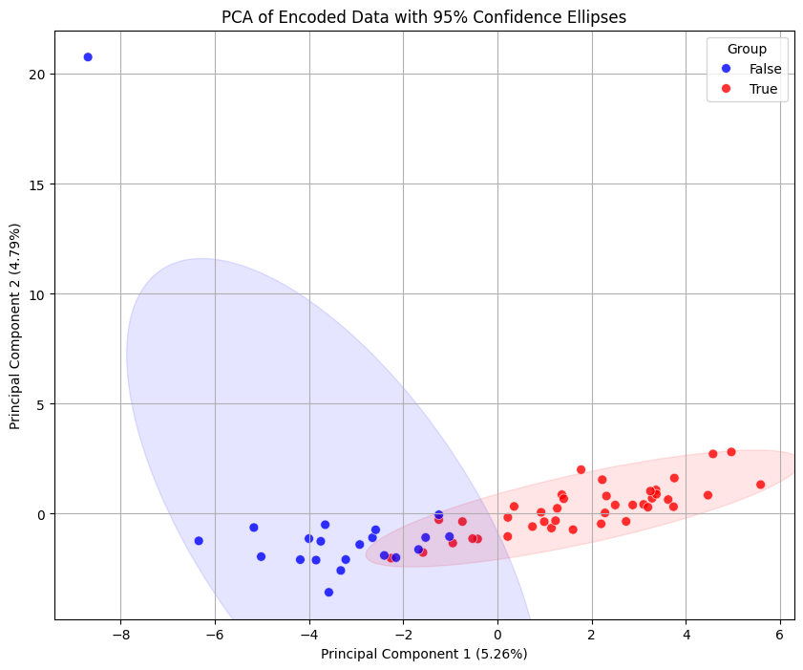
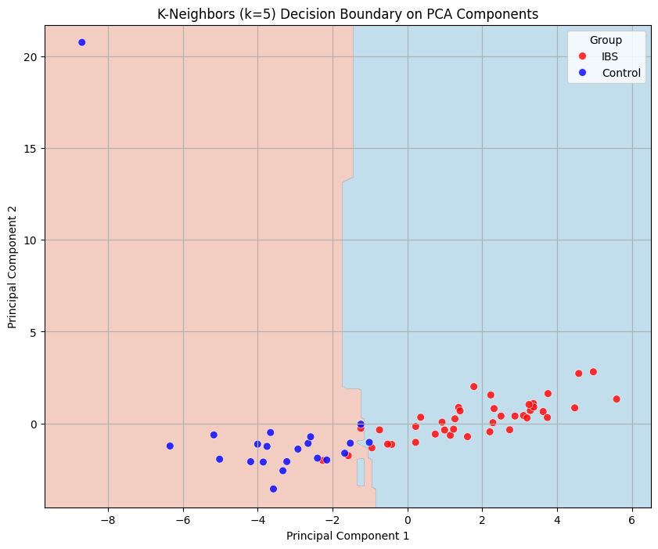K-Neighbors decision

